Converting an RA to an LA compensator is doable and pretty easy.
You have to apply an M5 x 0,8 plug into the delta p spool. Pos 32.,
PN needed P2-075-0806-01N COMPENSATOR ASSY LA UNC R NBR
Best way to do this is to remove the back plug on the compensator (no. 4) and pull out the spool.
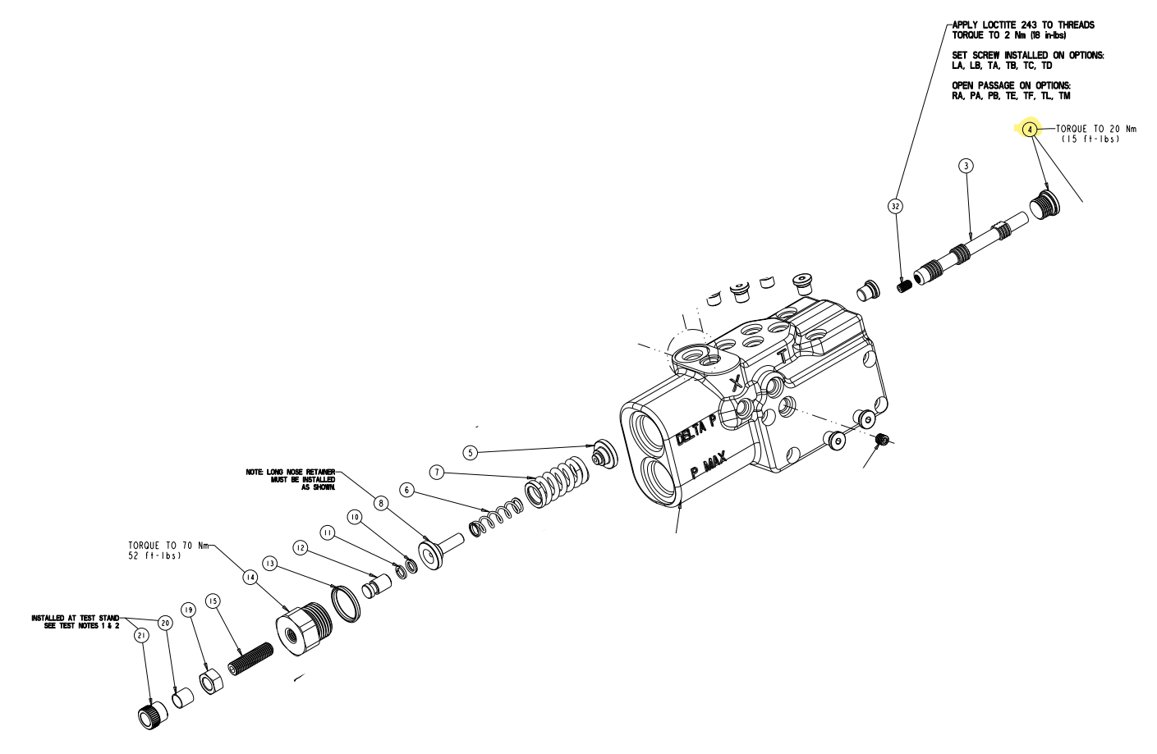
Option two is to remove the other side (No 14, with the set screw etc.) and No. 5-8 is also possible. Just pay attention when you assemble it again.

